**Name : Tanishq Thuse**

**Branch : SY-CS(AI)**

**Div : B**

**Roll No. : 60**

**Subject : ADS Assignment-2**

**Title : Student DataBase**

**Q1) Student database using array**

Code :

#include <stdio.h>

#include <stdlib.h>

#include <string.h>

struct Student {

char name[100];

int roll;

float CPI;

};

// Function to check for duplicate roll numbers and return a valid one

int checkRollNo(struct Student students[], int index) {

int r;

while (1) {

printf("Enter roll number :\n");

scanf("%d", &r);

int duplicate = 0;

for (int i = 0; i < index; i++) {

if (students[i].roll == r) {

printf("Roll number already exists. Please enter a different roll number\n");

duplicate = 1;

break;

}

}

if (!duplicate) {

return r;

}

}

}

// Function to add a student

void addStudent(struct Student students[], int index) {

printf("Enter name :\n");

scanf("%s", students[index].name);

students[index].roll = checkRollNo(students, index);

printf("Enter CPI :\n");

scanf("%f", &students[index].CPI);

}

// Function to delete a student by roll number

int deleteStudent(struct Student students[], int index) {

printf("Enter roll no. of student to delete\n");

int r;

scanf("%d", &r);

int found = 0;

for (int i = 0; i < index; i++) {

if (students[i].roll == r) {

found = 1;

for (int j = i; j < index - 1; j++) {

students[j] = students[j + 1];

}

index--;

break;

}

}

if (!found) {

printf("Roll number not found\n");

}

return index;

}

// Function to display all students

void displayStudents(struct Student students[], int index) {

for (int i = 0; i < index; i++) {

printf("Name of student : %s\n", students[i].name);

printf("Roll number of student : %d\n", students[i].roll);

printf("CPI of student : %f\n", students[i].CPI);

printf("\n");

}

}

int createDataBase(struct Student students[]){

int index=0;

int n ;

printf("Enter number of students\n");

scanf("%d", &n);

for(int i=0; i<n; i++){

addStudent(students, index++);

}

return index;

}

int main() {

int index = 0;

int flag = 0;

struct Student students[50];

while (1) {

printf("Enter your choice : \n");

printf("0) Create Student Database\n");

printf("1) Add student\n");

printf("2) Delete student\n");

printf("3) Display student\n");

printf("4) Exit\n\n");

int choice;

scanf("%d", &choice);

switch (choice) {

case 0:

index = createDataBase(students);

break;

case 1:

addStudent(students, index);

index++;

break;

case 2:

index = deleteStudent(students, index);

break;

case 3:

displayStudents(students, index);

break;

case 4:

flag = 1;

break;

default:

printf("Invalid choice. Please try again\n");

break;

}

if (flag) {

break;

}

}

return 0;

}

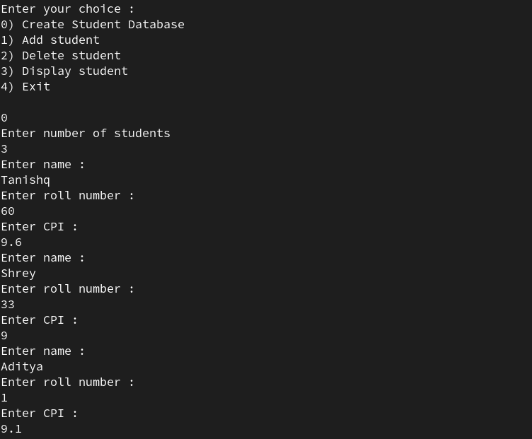

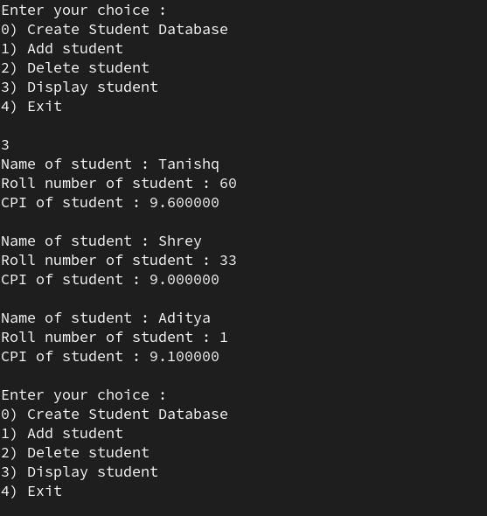

**Q2) Student Database using LinkedList**

Code :

#include <stdio.h>

#include <stdlib.h>

#include <string.h>

struct Student {

char name[100];

int roll;

float CPI;

struct Student* next;

};

int checkRollNo(struct Student* head, int roll) {

struct Student* current = head;

while (current != NULL) {

if (current->roll == roll) {

return 0;

}

current = current->next;

}

return 1;

}

struct Student* createStudentNode(char* name, int roll, float CPI) {

struct Student* newStudent = (struct Student*)malloc(sizeof(struct Student));

strcpy(newStudent->name, name);

newStudent->roll = roll;

newStudent->CPI = CPI;

newStudent->next = NULL;

return newStudent;

}

void addStudent(struct Student** head) {

char name[100];

int roll;

float CPI;

printf("Enter name :\n");

scanf("%s", name);

while (1) {

printf("Enter roll number :\n");

scanf("%d", &roll);

if (checkRollNo(*head, roll)) {

break;

} else {

printf("Roll number already exists. Please enter a different roll number\n");

}

}

printf("Enter CPI :\n");

scanf("%f", &CPI);

struct Student* newStudent = createStudentNode(name, roll, CPI);

newStudent->next = *head;

*head = newStudent;

}

void deleteStudent(struct Student** head) {

int roll;

printf("Enter roll no. of student to delete\n");

scanf("%d", &roll);

struct Student* current = *head;

struct Student* previous = NULL;

while (current != NULL && current->roll != roll) {

previous = current;

current = current->next;

}

if (current == NULL) {

printf("Roll number not found\n");

return;

}

if (previous == NULL) {

*head = current->next;

} else {

previous->next = current->next;

}

free(current);

}

void displayStudents(struct Student* head) {

struct Student* current = head;

while (current != NULL) {

printf("Name of student : %s\n", current->name);

printf("Roll number of student : %d\n", current->roll);

printf("CPI of student : %f\n", current->CPI);

printf("\n");

current = current->next;

}

}

void createDataBase(struct Student** head) {

int n;

printf("Enter number of students\n");

scanf("%d", &n);

for (int i = 0; i < n; i++) {

addStudent(head);

}

}

int main() {

struct Student* head = NULL;

int flag = 0;

while (1) {

printf("Enter your choice : \n");

printf("0) Create Student Database\n");

printf("1) Add student\n");

printf("2) Delete student\n");

printf("3) Display student\n");

printf("4) Exit\n\n");

int choice;

scanf("%d", &choice);

switch (choice) {

case 0:

createDataBase(&head);

break;

case 1:

addStudent(&head);

break;

case 2:

deleteStudent(&head);

break;

case 3:

displayStudents(head);

break;

case 4:

flag = 1;

break;

default:

printf("Invalid choice. Please try again\n");

break;

}

if (flag) {

break;

}

}

struct Student* current = head;

while (current != NULL) {

struct Student* next = current->next;

free(current);

current = next;

}

return 0;

}

**Output :**

